AIT MIL-STD 1553 VeriStand 2014 Driver version 1.0.0.2

Overview
The AIT MIL-STD 1553 Add-On allows users to use the AIT MIL-STD 1553 devices in the NI VeriStand environment. Avionics Interface Technologies (http://www.aviftech.com/) manufactures the hardware supported by this Add-On.
The driver ships in 30 day evaluation mode; after the 30 days have expired the driver will no longer run without a valid license. One will be able to still modify the VeriStand system definition file, but one will not be able to run.
Overview of the MIL-STD 1553 protocol
http://en.wikipedia.org/wiki/MIL-STD-1553

Before Getting Started
This document assumes the user is familiar with the operation of VeriStand, the MIL-STD 1553 protocol, and AIT’s Flight Simulyzer software. An overview of MIL-STD 1553 and the Flight Simulyzer software is provided by AIT and can be found in the “AIT MIL-STD 1553 LabVIEW Users Guide” which is supplied by AIT, and is installed once the AIT MIL-STD 1553 LabVIEW driver is installed.

Registering AIT’s Software
The AIT MIL-STD 1553 VeriStand 2014 Driver leverages tools supplied by AIT’s Flight Simulyzer application to automatically convert the AIT XML configuration file to a device specific BIN file that runs on the AIT MIL-STD 1553 hardware. By default the AIT software will run for 30 days before requiring registration, however If those tools are not registered with AIT the AIT MIL-STD 1553 VeriStand 2014 Driver will fail to run after 30 days. This is a separate license than the license required for the AIT MIL-STD 1553 VeriStand 2014 Driver.
The registration process for the AIT tools can be found in “AIT MIL-STD 1553 LabVIEW Users Guide\Converting the XML Configuration to Loadable BIN”.

Installing the AIT MIL-STD 1553 VeriStand 2014 Driver
With NI VeriStand closed:
- If not already installed, download and install NI-VISA available at ni.com
Note: Only the Run Time Engine and Real-Time support items in the installer are required
- Install the AIT MIL-STD 1553 LabVIEW driver from www.aviftech.com, version 2.39.0.
ait1553-win-labview-visa-32-2.39.0.exe
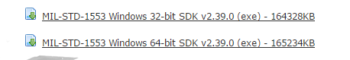
- Reboot.
- Run the AIT MIL-STD 1553 VeriStand 2014 Driver 1.0.0.2 Installer.msi
- The installer will place the driver into your "<Public Documents>\National Instruments\<VeriStand>\Custom Devices\" directory.
Note: This driver is only supported in VeriStand 2014.
- Using Measurement and Automation Explorer (MAX), install NI-VISA and AIT MIL-STD 1553 Driver Support to your Real-Time target
  - Open MAX
  - Expand remote systems
  - Select and expand your target
  - Right click software and select add/remove software
  - Select NI VISA -> Install This Feature
  - Select AIT MIL-STD 1553 Driver Support -> Install This Feature
  - Select Next to install
- If not done already, reboot your Real-Time target

Quick Start – Test 1553
The driver ships with a sample Simulyzer file that allows one to setup a simple test requiring no external devices. This file consists of a BC, BM, and RT. The RTs are in simulation mode so no other hardware is required to get a response from them. The parameters loop back internally through the system so one may toggle values of an RT parameter and see the result reflected in the BC message parameter (and vice-versa). There are two files required for this quick start:

- “Test 1553.xml” – AIT Simulyzer file
- “Test 1553-Parameters.xml” – VeriStand parameters file

Both files, and this readme file, reside in <Public Documents>\National Instruments\NI VeriStand 2014\Custom Devices\AIT 1553\Documents.

Running the Demo
- Ensure all the drivers and hardware are installed (no external cabling needed)
- Start VeriStand and create a new project.
- Configure the Operating System of the target (PharLap for PXI) and set the IP address to that of the Controller.
- Add the AIT MIL-STD 1553 Custom device to the system definition and enable Bus 1.
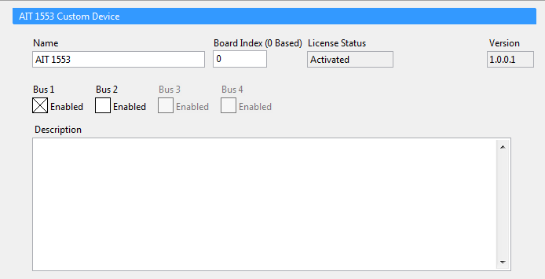

5. Select the “BusName1” tree object and press the “Load Database” button at the top of the System Explorer screen and navigate to "C:\Users\Public\Documents\National Instruments\NI VeriStand 2014\Custom Devices\AIT 1553\Documents\Test 1553.xml". This will import the Flight Simulyzer file and the corresponding parameter file.
6. Optional – Activate license for the driver. Status of the license is shown on the custom device page.
7. Explore the different sections of the BUS to see the relationship of the parameters. Under each message there are multiple parameters.
Bus Controller Configuration from Simulyzer
Transmit Message
Get_It: RT Address 5, RT Sub Address 4
Parameter: Data_00
Receive Message
Gun_One: RT Address 11, RT Sub Address 10
Parameter: Data_01
Receive Message
Gun_Two: RT Address 11, RT Sub Address 5
Parameter: Data_02
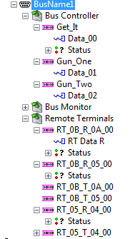

Bus Monitor Configuration from Simulyzer
Only one parameter is defined although the BM configuration is set up to review Rx and Tx on all sub-addresses of RT 5 and RT 11:
Message:
BM_05_T_04: RT Address 5, RT Sub Address 4
Parameter: BM_Data_Parm_1
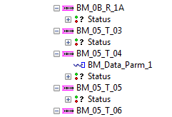
Remote Terminal Configuration from Simulyzer
Two parameters are defined in the RT section to provide locations to receive data from the BC and send data to the BC. All messages are centric to the Remote Terminal, therefore on the Bus Controller, a receive message is actually data sent to the remote terminal. Conversely, a transmit message on the Bus Controller is data sent from the RT to the BC. From the remote terminal perspective, the convention is as you would expect.
Receive Message:
RT_0B_R_0A_00: RT Address 11, RT Sub Address 5
Parameter: RT Data R
Transmit Message:
RT_05_T_0A_00: RT Address 11, RT Sub Address 5
Parameter: RT Data T
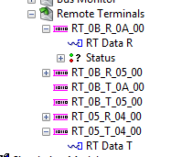
8.
Optional – Add or remove parameters on a message by right clicking on the message and selecting:
- Add Data Parameter – Adds a single U8 parameter starting in the first byte of the message at start bit 0.
- Add Parameter… - Add multiple parameters all at once
- Add Parameter for Each Bit – Add a paramter for each bit
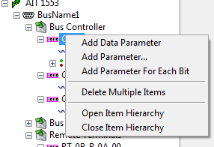

9. Optional – If you have created any new paramters save them to an external file by right clicking on “BusName1” and selecting ‘Export Database Parameters’. This would allow one to take a given paramter definition and import it into a new VeriStand System Explorer. Performing this saves the parameters asscoiated with the simulyzer configuration outside of the VeriStand system definition file. If the sysdef file is corrupted or deleted, the parameters can be easily restored upon loading of the same named simulyzer file again, saving much time re-entering parameters.
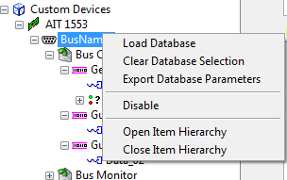

10. Save the System Definition and run VeriStand. If you have not yet activated your license you will be asked to activate now or continue your 30 day trial period.
11.
Once your VeriStand WorkSpace has loaded add controls and indicators for each of the defined parameters.

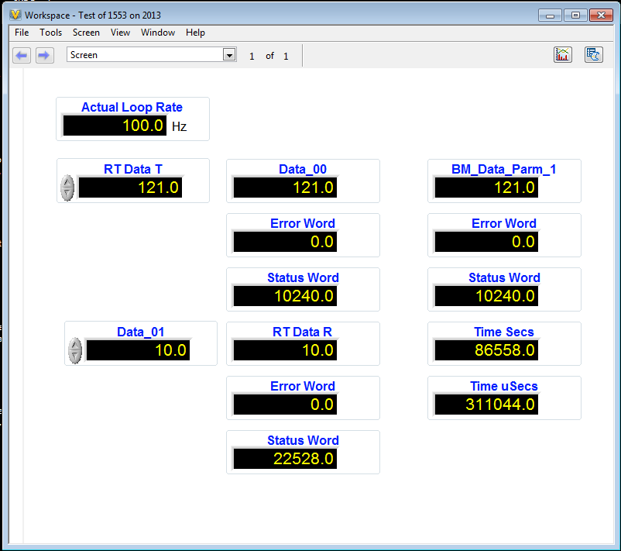

12. Testing the driver
The relationship between these parameters is defined using the RT addresses, sub-addresses, and the parameter definition (start byte, offset, scale, etc…)
Setting values for RT Data T will reflect in Data_00
Setting values for Data_01 will reflect in RT Data R

The Bus Monitor parameter is set to reflect the value associated with the RT Data T parameter.

Timestamp data is available on the Bus Monitor parameters.

Add-On Requirements
Software
This device was created for use with NI VeriStand 2014. To use this custom device you must have the following software installed:
- NI VeriStand 2014
- NI-VISA
- AIT MIL-STD 1553 LabVIEW Driver 2.39.0
- AIT MIL-STD 1553 VeriStand 2014 Driver (downloaded with this driver)

Hardware
This add-on requires MIL-STD 1553 hardware from AIT. The following interfaces will work and have been tested. Other, similar AIT MIL-STD 1553 devices should work but have not been tested.
· USB1553 (Window’s execution – not deterministic)
· PXI-C1553-2 (Real-Time execution)

Supported Features (Limitations)
1. Flight Simulyzer Database (XML) Support
The definition of the configuration is made in the Flight Simulyzer. Once loaded into the device in VeriStand, parameters can be added. In order to preserve the ability to modify the Database without losing parameters, an export feature is available. A text file named the same as the Database is created alongside, with a “–Parameters” suffix added. Upon loading of a Database, if a parameter file is present, the two will be merged.
E.g.
Test 1553.xml
Test 1553-Parameters.txt
2. Currently only one board can be used
3. Multiple Bus’ are supported
Although the Bus page shows up to four, only one is implemented.
4. One Major Frame is supported.
5. Buffer Depth (Flight Simulyzer Definition)
Only a single buffer depth is supported. In the simulyzer file, a buffer depth of 1 must be specified.
6. Supported messages include:
BC-RT – BC send data to RT
RT-BC – Request RT to send data to BC
RT-RT –RT to RT transfer (no data is available to the BC)
7. Acyclic Frames
If defined, Acyclic Frames show up in the BC section. The message/data is available for setting or viewing just like a periodic message. The Acyclic frame is a Boolean trigger that is used to send the frame immediately. Frames are listed in the order as defined in the Database 0…n
8. Mode Codes
Mode Codes are defined in the Flight Simulyzer file and present as either BC-RT or RT-BC messages. They have either zero data or one data words associated with them.
9. Error and Status Words
Bus Controller
BC-RT – Not Supported
RT-BC – Both Supported
RT-RT – Not Supported
Bus Monitor
All messages in the BM support error and status words
Remote Terminals
BC-RT – Supported
RT-BC – Not Supported
10. Timestamping of Data
Timestamping returns the time in seconds (U32) and fractional microseconds (U32)
Bus Controller
BC-RT – Not Supported
RT-BC – Not Supported
RT-RT – Not Supported
Bus Monitor
All messages in the BM support Timestamping
Remote Terminals
BC-RT – Not Supported
RT-BC – Not Supported
11. Database Path
Absolute
12. Board Initialization
By index, not serial number

Known Issues
- Initial Release

Notes on Source, Theory of operation
This is an in-line custom device that launches five parallel loops (for TX and RX on each sub-section: BC, BM, RT) and communicate to/from them with RT FIFOs. The in-line portion going at the NIVS rate does no driver calls; it just reads and writes the RT FIFOs. At initialization the custom device uses the Minor Frame rate of the BC and sets the loop rates for BC, BM, and RT to twice that speed. Data read from the hardware is passed back to the inline driver through the RT FIFOs and similarly, data for output is passed to the asynchronous loops through RT FIFOs. Two buffers (In and Out) are used to manage the data coming from/going to the FIFOs.

Change Log

1.0.0.2
- <Change> Aligned the Read Rate Fields on the RT and BM configuration pages
- <Bug>
- <Feature>

1.0.0.1- Initial release.

